**Add a new JIRA project to MARV**

As MARV currently stands there are 17 places that you must add a new project. I hope to centralize it eventually but for now:

The project page should have a url similar to: https://jira.webfilings.com/plugins/servlet/project-config/AD/versions

In this case the project key is “AD”. The key is important – we will use it throughout this process.

First edit background.js, there are **8** places it the new key will need to be added. Always add it to the end of the list.

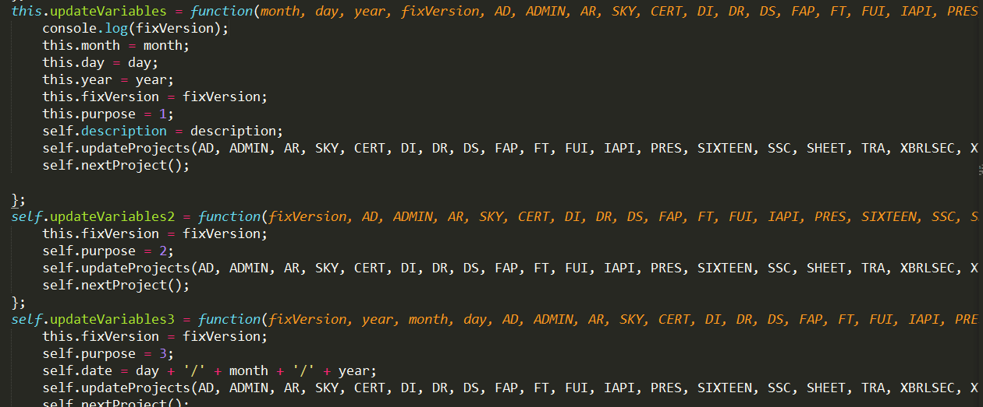

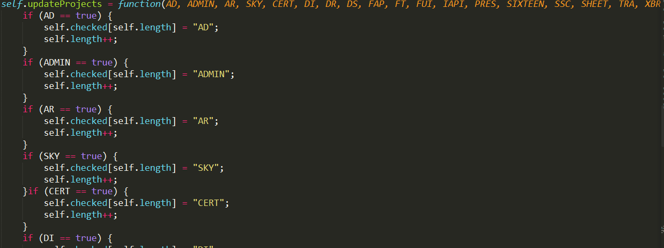

At the end of this list add another if statement with the new key. The if statement should list the key 3 times.

After all 8 edits are made to background.js make 1 edit to popup.html

A new table cell (and possibly a table row) will need to be added. This is basic HTML so there should be some online guides to show you how to add a row and shift things down etc. I like to keep the checkboxes in alphabetical order.

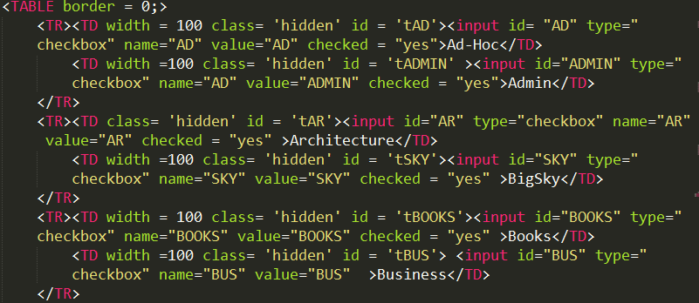

Finally, the file popup.js will need to be changed in 8 places.

The new key will need to be added twice to each of these methods. Always place it at the end of the list of keys.

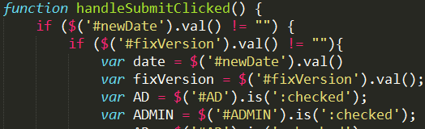handle SubmitClicked()

Location 1 for handleSubmitClicked(), handleSubmit2Clicked(), and handleSubmit3Clicked()

handleSubmit2Clicked()

handleSubmit3Clicked()

Location 2 for handleSubmitClicked(), handleSubmit2Clicked(), and handleSubmit3Clicked()



The key will also need to be added to the list for two more methods. These are:

handleHideProjClicked()

handleShowProjClicked()

Congrats! You are done.